The Original 13 Project Requirements
Task: In cooperative groups, you will create a map and a poster for an assigned colony. This is a very important responsibility. The world will see your work, and you will have the power to build up the American colonies through immigration. Your goal is to persuade immigrants that your colony is the best place for settlement. Remember the statement of inquiry: Colonization occurs for political, economic, or social reasons. So, WHY should I choose to settle in your colony? Also, remember the unit question: How does geography affect the development of societies?
Requirements:
1. Make a map of the colony and label the name of the colony. The following information should be creatively placed on the map:
- Label the colony as a New England Colony, Middle Colony or Southern Colony.
- Pinpoint the larger settlements on the map.
- Include landforms.
- Write when it was settled.
- Show the origin of settlers: Spain, France, Sweden, Holland, or England.
- Identify the economy: fishing, farming (be specific about type of farming), etc.
2. Make an informational poster about the colony that will complement the poster. The following information will need to be included:
- What is the daily life like?
- What type of government do you have?
- How did your colony create its laws?
- What can people do to make money in your colony?
- What is the climate like?
- What kind of natural resources do you have?
- What do you do for entertainment?
- What are the religious beliefs of people in your colony?
- Do you permit slaves?
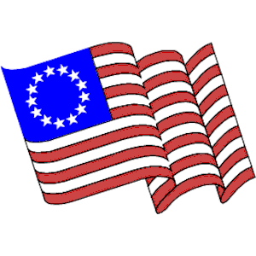
Remember: Your goal is to persuade someone to settle in your colony and create a professional quality product!

